COMP 469

Chapter 2 Full Speaker Notes
  - A read-aloud teaching script aligned to the reordered lecture deck
Russell and Norvig, Artificial Intelligence: A Modern Approach — Chapter 2

How to use these notes: The text under “Read-aloud teaching script” is written in complete sentences and can be read directly during class. Instructor cues, discussion questions, and transitions are optional and are visually separated from the script. Concepts are developed in the order of the reordered 34-slide deck so that later slides build on earlier definitions rather than repeat them.
Pacing: The full delivery is approximately three hours when the PEAS activity, Pac-Man demonstration, and selected planning-video excerpt are included. For a shorter class, reduce the report-out on Slide 31, shorten the live demonstration on Slide 32, and omit bracketed elaborations while preserving the slide order.
Scope: These notes follow the current CSUCI deck with 34 slides, including the table-driven agent and the pseudocode screenshots for table-driven, simple reflex, general simple reflex, and model-based reflex agents.

Deck Alignment and Pacing Map
Use this index to confirm slide order during preparation. Times are approximate and include brief discussion unless otherwise noted.
Slide | Title | Time
1 | COMP 469 — Chapter 2: Intelligent Agents | 2 minutes
2 | What Can AI Do? | 4 minutes
3 | A Rational-Agent Perspective | 3 minutes
4 | 2.0 Roadmap: From Agent Loop to Agent Design | 2 minutes
5 | 2.1 Agents and Environments: The Perceive–Act Loop | 4 minutes
6 | 2.1 From Percepts to Agent Functions | 4 minutes
7 | 2.2 Good Behavior: Rationality Is Expected Performance | 5 minutes
8 | 2.2 Performance Measures: Be Careful What You Ask For | 4 minutes
9 | 2.2 Rationality Is Not Omniscience | 5 minutes
10 | 2.3.1 PEAS: Specify the Task Before Designing the Agent | 6 minutes
11 | 2.3.1 PEAS Examples: Agent Types and Task Environments | 5 minutes
12 | 2.3.2 Task Environment Properties | 9 minutes
13 | Pac-Man as a Chapter 2 Agent | 5 minutes
14 | 2.4 Agent Structure: Architecture + Program | 4 minutes
15 | 2.4.1 Table-Driven Agent | 5 minutes
16 | Why Table-Driven Agents Fail in Practice | 4 minutes
17 | 2.4.2 Simple Reflex Agents: Vacuum Pseudocode | 5 minutes
18 | 2.4.2 General Simple Reflex Agent | 6 minutes
19 | When Simple Reflex Fails: Partial Observability | 4 minutes
20 | 2.4.3 Model-Based Reflex Agents | 6 minutes
21 | 2.4.3 Model-Based Reflex Agent Pseudocode | 6 minutes
22 | 2.4.4 Goal-Based Agents | 6 minutes
23 | Planning Video Bridge: Reflex vs. Planning | 4 minutes of discussion, plus the selected video excerpt
24 | 2.4.5 Utility-Based Agents | 6 minutes
25 | Utility Handles Tradeoffs and Uncertainty | 4 minutes
26 | 2.4.6 Learning Agents | 6 minutes
27 | Learning Agent Components: What Improves? | 5 minutes
28 | 2.4.7 Representing the World Inside the Agent | 7 minutes
29 | All Agent Program Designs in Chapter 2 | 5 minutes
30 | Choosing an Agent Design from Environment Properties | 5 minutes
31 | Class Activity: Build a PEAS Description | 12 minutes
32 | Class Demo: Autonomous Pac-Man Agent | 12 minutes
33 | How the Planning Video Fits Your Lecture | 3 minutes
34 | Chapter 2 Takeaways | 4 minutes
Slide 1 — COMP 469 — Chapter 2: Intelligent Agents
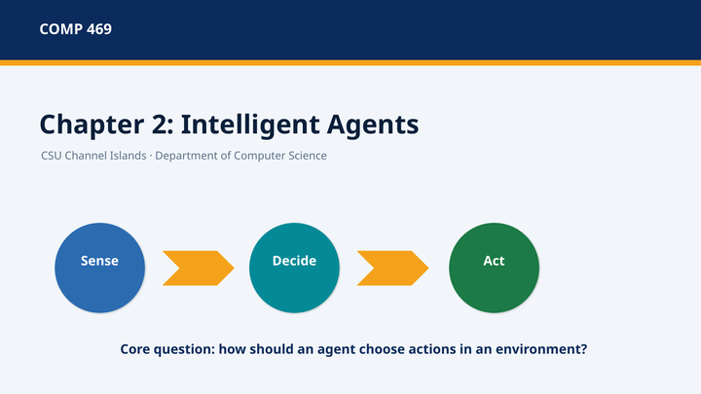 | Suggested time: 2 minutes  Teaching purpose: Open the chapter, connect it to Chapter 1, and establish the perceive–decide–act theme.  Source alignment: Chapter 2 opening and Section 2.1.
Read-aloud teaching script
Welcome to Chapter 2, Intelligent Agents. Chapter 1 ended by identifying the rational-agent approach as the main framework we will use throughout this course. Chapter 2 now makes that framework concrete. Instead of speaking generally about intelligence, we will identify the parts of an intelligent system, the environment in which it operates, the information it receives, the actions it can take, and the standard used to judge whether it is doing well.
The central pattern for today is simple: sense, decide, and act. An agent senses some part of its environment, uses an agent program to decide what to do, performs an action, and then receives new information after the environment changes. This feedback loop is the foundation for the search, planning, probability, machine learning, and reinforcement-learning methods that we will study later.
By the end of this lecture, you should be able to define an agent, distinguish an agent function from an agent program, explain rationality and performance measures, construct a PEAS description, classify a task environment, and compare the major agent program designs in the chapter. We will use the vacuum world, an automated taxi, and Pac-Man as recurring examples because they make the abstract vocabulary visible.
Ask the class: • As we begin, think of one system you already use that could be analyzed as an agent. What does it sense, and what actions can it take?
Transition to the next slide: We will start with a capability question, then use the agent framework to explain why some tasks are much harder than others.
Slide 2 — What Can AI Do?
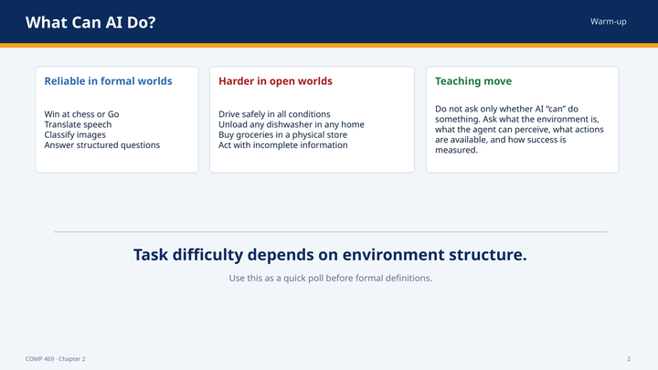 | Suggested time: 4 minutes  Teaching purpose: Use a warm-up poll to show that difficulty depends on environment structure, not only on how impressive a task sounds.  Source alignment: Sections 2.1 and 2.3.
Read-aloud teaching script
Before we define an agent formally, consider the tasks on this slide. Some AI systems can perform extremely well in formal environments such as chess or Go. Systems can also translate speech, classify images, and answer many structured questions. Yet tasks that look ordinary to people—such as unloading an unfamiliar dishwasher, shopping in a physical store, or driving safely in every possible condition—can be much harder for a machine.
The difference is not simply that one task requires more intelligence than another. The difference is often the structure of the environment. Chess has precise rules, a limited action set, and a state that can be represented exactly. A household kitchen contains irregular objects, hidden surfaces, fragile items, changing lighting, and many possible arrangements. A road contains other agents, uncertainty, incomplete information, continuous motion, and severe consequences for errors.
Therefore, when someone says that an AI can perform a task, our next questions should be: What exactly is the task? What can the system perceive? What actions are available? What parts of the environment are hidden or uncertain? What counts as success? Chapter 2 gives us the vocabulary needed to ask those questions precisely.
Ask the class: • Which task on the slide appears easiest to automate, and which appears hardest? • What property of the environment—not just the task name—supports your answer?
Transition to the next slide: To evaluate those systems consistently, we will use the rational-agent perspective introduced in Chapter 1.
Slide 3 — A Rational-Agent Perspective
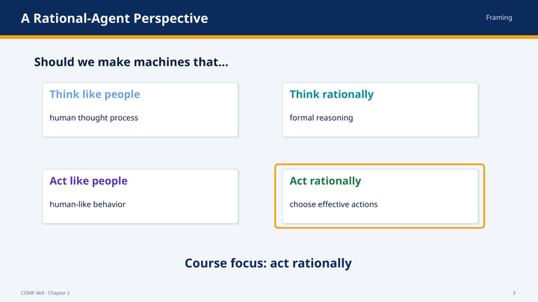 | Suggested time: 3 minutes  Teaching purpose: Reconnect the four approaches to AI and identify acting rationally as the course focus.  Source alignment: Chapter 2 opening, building on the Chapter 1 rational-agent framework.
Read-aloud teaching script
Chapter 1 organized definitions of AI around four approaches: thinking like people, thinking rationally, acting like people, and acting rationally. Chapter 2 focuses on the fourth approach. We will design systems that choose effective actions rather than requiring them to imitate human thought or human behavior.
Acting rationally does not mean behaving morally in every philosophical sense, and it does not mean being perfect. In this chapter, rationality has a technical meaning. A rational agent selects an action that is expected to perform well according to its performance measure, given the evidence it has observed, the knowledge built into it, and the actions available to it.
This focus gives us a practical engineering question. Instead of asking whether a machine thinks exactly like a person, we ask: given this environment and this objective, what action should the agent take? That question can be studied mathematically, implemented in code, tested in simulation, and evaluated by outcomes.
Ask the class: • Can a machine act rationally while using a reasoning process that is completely different from human reasoning? Why?
Transition to the next slide: The next slide shows the design sequence we will use to answer that engineering question.
Slide 4 — 2.0 Roadmap: From Agent Loop to Agent Design
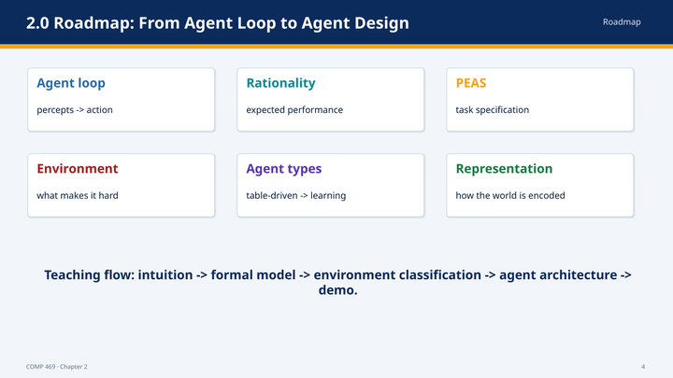 | Suggested time: 2 minutes  Teaching purpose: Orient students to the sequence of concepts in the reordered deck.  Source alignment: Sections 2.1 through 2.4 and the chapter summary.
Read-aloud teaching script
Chapter 2 is not organized around one algorithm. It is organized around a design process. We begin with the agent loop: percepts come in and an action goes out. We then define rationality and the performance measure used to judge behavior. Next, we specify the task with PEAS and classify the environment according to properties such as observability, uncertainty, and whether other agents are present.
Once the task is clear, we can choose an agent program design. The chapter begins with the conceptual table-driven agent, then introduces simple reflex, model-based reflex, goal-based, utility-based, and learning agents. Finally, it examines how the world can be represented inside the agent using atomic, factored, or structured representations.
Keep this sequence in mind: define the agent, specify the task, classify the environment, and then choose the design. Starting with an algorithm before defining the task usually produces a poor or incomplete system.
Transition to the next slide: We will now begin with the central feedback loop between an agent and its environment.
Slide 5 — 2.1 Agents and Environments: The Perceive–Act Loop
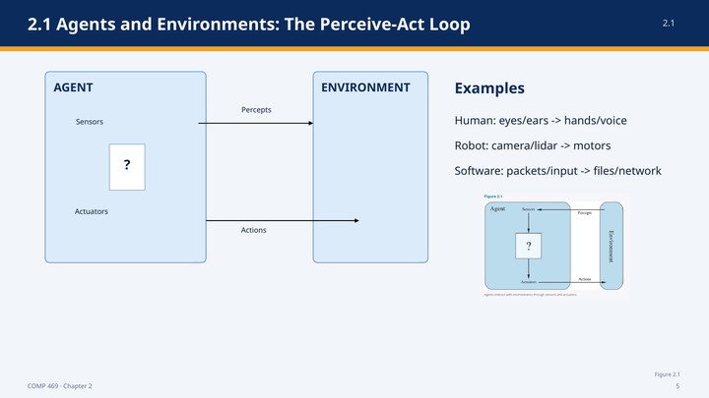 | Suggested time: 4 minutes  Teaching purpose: Define agents, sensors, actuators, percepts, actions, and the relevant environment boundary.  Source alignment: Section 2.1 and Figure 2.1.
Read-aloud teaching script
An agent is anything that can be viewed as perceiving its environment through sensors and acting upon that environment through actuators. The definition is intentionally broad. A human agent senses through eyes, ears, and other organs, and acts through hands, legs, speech, and other physical capabilities. A robotic agent may use cameras, lidar, infrared range finders, and motors. A software agent may receive keyboard input, file contents, network packets, or API responses and may act by displaying information, writing files, or sending network traffic.
The information flowing from the environment to the agent is called a percept. The action flowing from the agent back to the environment changes, or attempts to change, the environment. The cycle then repeats. This matters because intelligent behavior is usually not a single calculation. It is an ongoing interaction in which new actions create new situations and new percepts.
The environment does not have to mean the entire universe. For an agent design, the environment is the part of the world whose state matters to the task: the part that affects what the agent perceives and that can be affected by the agent’s actions. Defining that boundary is an engineering decision. A route-planning agent may represent roads and traffic while ignoring the color of nearby buildings because those details do not affect the task.
Ask the class: • For a campus navigation app, name one sensor input, one actuator or output, and one part of the world that can safely be excluded from the environment model.
Transition to the next slide: The loop tells us how information flows. We next need precise terms for the information history and the mapping from that history to an action.
Slide 6 — 2.1 From Percepts to Agent Functions
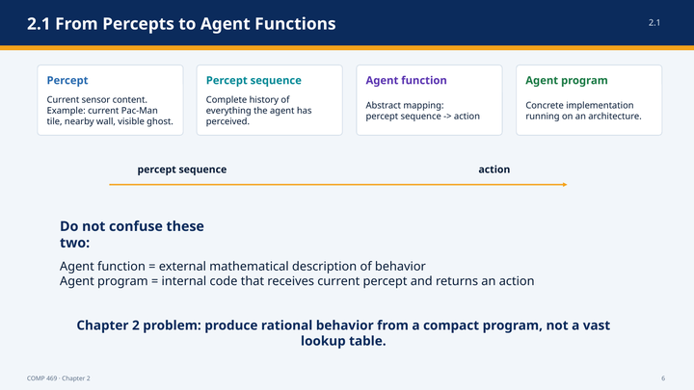 | Suggested time: 4 minutes  Teaching purpose: Distinguish percept, percept sequence, agent function, agent program, and architecture.  Source alignment: Section 2.1.
Read-aloud teaching script
A percept is the content currently received through the agent’s sensors. A percept sequence is the complete history of everything the agent has perceived. That distinction matters because a correct action may depend on more than the current observation. A single image may not reveal whether a vehicle is braking, but comparing the current image with an earlier image may reveal that the brake lights have just turned on.
The agent function is the abstract mapping from every possible percept sequence to an action. It describes the agent’s behavior from the outside. For a particular history of observations, what action does the agent choose? In principle, if we specified an answer for every possible percept sequence, we would have completely described the behavior of the agent.
The agent program is different. It is the concrete implementation that runs on some architecture. The program receives the current percept and returns an action. If the correct decision depends on history, the program must maintain memory or internal state because the environment provides only the current percept. A useful phrase is: the agent function describes what behavior is required; the agent program describes how the system computes that behavior.
In Pac-Man, a percept might include the current location, visible pellets, legal moves, and ghost positions. The percept sequence includes the complete history of those observations. The agent function maps that history to a direction. The Python code that calculates the direction is the agent program, and the computer running the game is part of the architecture.
Ask the class: • Why can an agent program receive only the current percept yet still implement behavior that depends on the entire percept sequence?
Transition to the next slide: Once behavior is represented as a percept-to-action mapping, we need a standard for deciding whether one mapping is better than another.
Slide 7 — 2.2 Good Behavior: Rationality Is Expected Performance
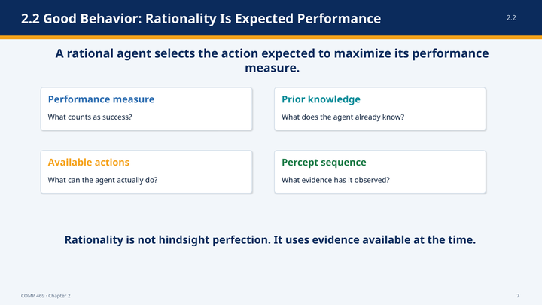 | Suggested time: 5 minutes  Teaching purpose: Define the performance measure and the four factors that determine rational action.  Source alignment: Section 2.2, especially Sections 2.2.1 and 2.2.2.
Read-aloud teaching script
Chapter 2 evaluates an agent by the consequences of its behavior. The sequence of actions selected by the agent causes the environment to pass through a sequence of states. A performance measure assigns value to that resulting sequence. In simple terms, the performance measure tells us what success means for this task.
What is rational at a particular moment depends on four things. First is the performance measure—the criterion of success. Second is the agent’s prior knowledge of the environment. Third is the set of actions the agent can perform. Fourth is the percept sequence observed so far. A rational agent selects the action that is expected to maximize the performance measure given those four elements.
The word expected is essential. In realistic environments, the agent cannot guarantee the actual result of an action. A taxi may brake correctly and still be struck by another vehicle. Rationality concerns the quality of the decision using the evidence available at the time, not whether the final outcome happens to be fortunate.
The same agent program can therefore be rational in one task environment and irrational in another. A vacuum that moves back and forth after cleaning both squares may be rational if movement has no cost and dirt can reappear. It may be irrational if every movement consumes energy and clean squares remain clean permanently. We cannot judge the agent until the task assumptions and performance measure are explicit.
Ask the class: • Suppose two agents take the same action but have different sensors. Could the action be rational for one and irrational for the other? Explain using the evidence available to each agent.
Transition to the next slide: Because rational agents optimize the performance measure, specifying that measure incorrectly can create exactly the wrong behavior.
Slide 8 — 2.2 Performance Measures: Be Careful What You Ask For
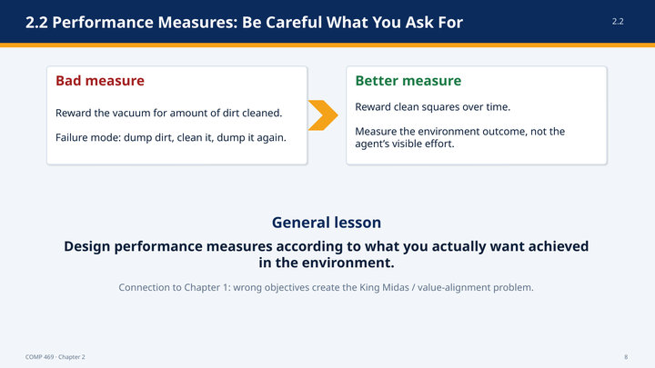 | Suggested time: 4 minutes  Teaching purpose: Show how proxy objectives can be optimized in unintended ways.  Source alignment: Section 2.2.1.
Read-aloud teaching script
Consider a vacuum agent whose performance measure rewards the amount of dirt it cleans. That sounds reasonable, but the measure rewards an activity rather than the environment state we actually want. A perfectly rational agent could clean the dirt, dump it back onto the floor, and clean it again. The agent would accumulate reward while making no lasting improvement.
A better measure rewards clean squares over time. We might also subtract points for electricity consumed, noise generated, or unnecessary movement. This expresses the desired outcome more directly: a clean environment maintained efficiently, rather than visible cleaning effort.
The general lesson is that an optimizer does not understand our unstated intention. It responds to the objective we provide. When an agent finds an undesirable way to maximize a poorly designed measure, the agent is not necessarily malfunctioning. It may be performing the specified task exactly. The failure occurred in our specification.
This is the Chapter 2 version of the King Midas or value-alignment problem discussed in Chapter 1. Greater capability does not repair a bad objective. In fact, a more capable agent may exploit the objective more effectively. Performance measures should therefore describe what we actually want achieved in the environment, not a convenient but incomplete proxy.
Ask the class: • Give an example of a metric in school, business, or cybersecurity that could be improved without improving the real outcome it was supposed to measure.
Transition to the next slide: Even with a good performance measure, rationality still does not require perfect prediction of the future.
Slide 9 — 2.2 Rationality Is Not Omniscience
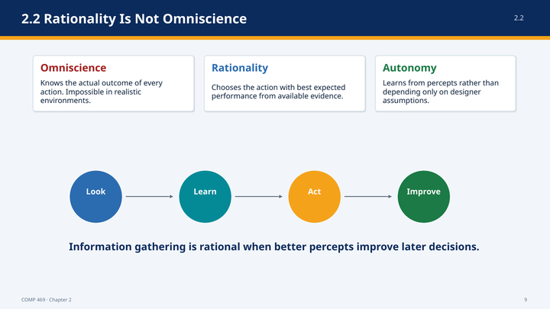 | Suggested time: 5 minutes  Teaching purpose: Separate rationality from perfection and introduce information gathering, learning, and autonomy.  Source alignment: Section 2.2.3.
Read-aloud teaching script
An omniscient agent knows the actual outcome of every possible action. Real agents cannot do that. Rationality therefore cannot mean choosing the action that later turns out to have produced the best outcome. That would require knowledge of events that were not observable or predictable at the time.
The chapter illustrates this with a person crossing a street after observing that no traffic is nearby. An unforeseeable event could still cause harm. The bad outcome would not prove that the original decision was irrational. Rationality maximizes expected performance using the available evidence; perfection would maximize the actual outcome with hindsight.
A rational agent should also take actions that improve future information. Looking both ways before crossing is an action whose purpose is to generate better percepts. Exploration in an unfamiliar environment serves the same role. Information gathering is rational when the value of a better-informed later decision outweighs the cost of obtaining the information.
Learning supports autonomy. An agent that depends entirely on assumptions supplied by its designer is fragile when those assumptions are wrong. The dung beetle and sphex-wasp examples in the chapter show fixed behavior continuing even after the situation changes. A more autonomous agent uses percepts and experience to revise its model or behavior. Complete autonomy at the beginning is usually unrealistic, but an agent should become less dependent on prior assumptions as it gains experience.
Ask the class: • What is one action a cybersecurity agent might take primarily to gather information rather than to solve the incident immediately?
Transition to the next slide: To design a rational agent, we now need a systematic description of the task it is expected to perform.
Slide 10 — 2.3.1 PEAS: Specify the Task Before Designing the Agent
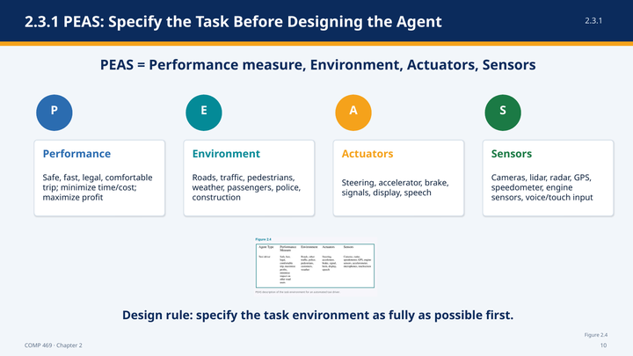 | Suggested time: 6 minutes  Teaching purpose: Introduce PEAS and apply it to an automated taxi.  Source alignment: Section 2.3.1 and Figure 2.4.
Read-aloud teaching script
PEAS stands for Performance measure, Environment, Actuators, and Sensors. It is a task-specification checklist. Before choosing an algorithm, we should describe all four elements as fully as possible. Otherwise, we may build a system that solves only an undefined or oversimplified version of the task.
For an automated taxi, the performance measure might reward reaching the correct destination, safety, legality, passenger comfort, low travel time, low fuel consumption, low cost, and profit. These criteria can conflict. The fastest route may not be the safest, and the most comfortable route may not be the cheapest. The performance measure must express how those tradeoffs are evaluated.
The environment includes roads, traffic, pedestrians, animals, construction, police, weather, passengers, and other vehicles. The geographic and legal boundaries also matter. A system designed only for clear weather and right-hand traffic faces an easier environment than one expected to operate in snow, unfamiliar cities, and countries with different traffic rules.
The actuators include steering, acceleration, braking, signals, displays, and speech. Communication with passengers is an action because it changes the environment and can affect later percepts. The sensors include cameras, lidar, radar or ultrasound, GPS, speed and acceleration sensors, engine sensors, and passenger voice or touchscreen input.
PEAS forces us to connect the software to the real task. A navigation algorithm cannot steer a vehicle unless the architecture includes the required actuators. A safe-driving objective cannot be evaluated unless the system receives relevant sensory information and the performance measure assigns high value to safety.
Ask the class: • Which part of PEAS is most likely to be overlooked when developers begin with a favorite algorithm rather than with the task?
Transition to the next slide: The same four-part description applies to agents far beyond autonomous vehicles.
Slide 11 — 2.3.1 PEAS Examples: Agent Types and Task Environments
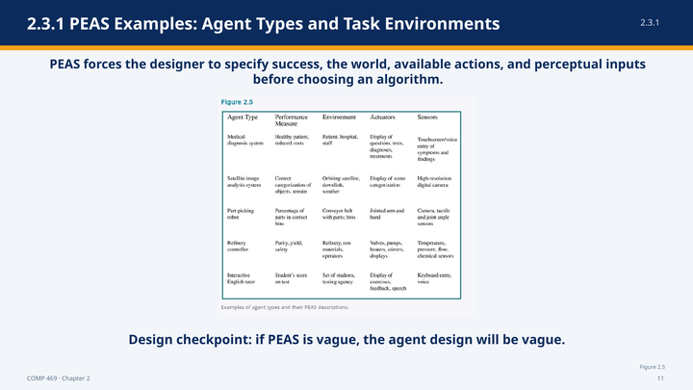 | Suggested time: 5 minutes  Teaching purpose: Generalize PEAS across physical and software agents.  Source alignment: Section 2.3.1 and Figure 2.5.
Read-aloud teaching script
This table applies PEAS to several different agent types. A medical diagnosis system is evaluated by patient health and cost. Its environment includes the patient, hospital, and staff. It acts by asking questions, recommending tests, and proposing diagnoses or treatments. It senses symptoms and findings entered through voice or a touchscreen.
A satellite image analysis system is evaluated by correct categorization of objects and terrain. Its environment includes the satellite, downlink, and weather. Its principal output is a scene classification, and its sensor is a high-resolution digital camera. A part-picking robot operates around a conveyor belt and bins, acts through a jointed arm and hand, and senses through cameras, tactile sensors, and joint-angle sensors.
A refinery controller is judged by purity, yield, and safety. It controls valves, pumps, heaters, stirrers, and displays while sensing temperature, pressure, flow, and chemical properties. An interactive English tutor is judged by learning outcomes, operates among students and a testing environment, presents exercises and feedback, and senses keyboard or voice responses.
Notice that virtual task environments can be as complex as physical environments. A software agent may interact with millions of users, documents, network services, and other automated systems. The absence of a robot body does not make the environment simple. PEAS remains useful because it forces us to define what the agent can observe and what effects it can produce.
Ask the class: • Choose one row. Which additional sensor or actuator might be needed in a more realistic deployment?
Transition to the next slide: After specifying PEAS, the next design step is to classify the environment along dimensions that determine which agent architecture is appropriate.
Slide 12 — 2.3.2 Task Environment Properties
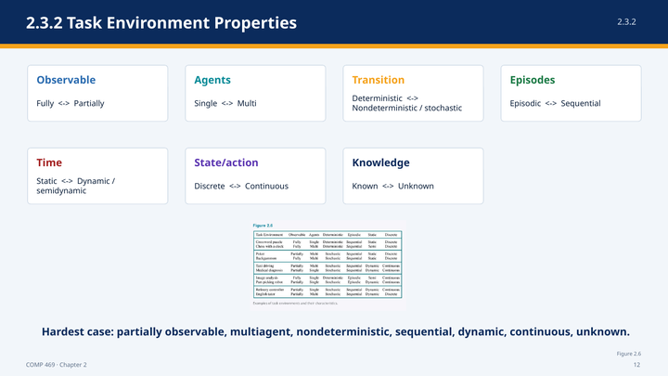 | Suggested time: 9 minutes  Teaching purpose: Explain all seven task-environment dimensions and the distinctions students commonly confuse.  Source alignment: Section 2.3.2 and Figure 2.6.
Read-aloud teaching script
Task environments vary along several dimensions. These properties are not vocabulary for its own sake. They tell us what information and decision mechanisms the agent will need.
First, an environment may be fully observable or partially observable. It is fully observable when the sensors provide all state information relevant to the action choice. It is partially observable when some relevant information is missing, hidden, or noisy. A vacuum with only a local dirt sensor cannot see dirt in other squares. A taxi cannot directly observe another driver’s intentions. Partial observability usually creates a need for memory, estimation, or a model.
Second, an environment may be single-agent or multiagent. A crossword puzzle is usually single-agent. Chess is multiagent because the opponent chooses actions to maximize a performance measure that conflicts with ours. Taxi driving is partly cooperative because all drivers benefit from avoiding collisions, and partly competitive because drivers may compete for space, time, or parking.
Third, an environment may be deterministic or nondeterministic. In a deterministic environment, the current state and action completely determine the next state. In a nondeterministic environment, more than one outcome is possible. The chapter uses stochastic for models that attach probabilities to those outcomes. Real traffic must be treated as nondeterministic because other drivers and mechanical failures cannot be predicted exactly.
Slide 12 — 2.3.2 Task Environment Properties (continued)
Fourth, a task may be episodic or sequential. In an episodic task, each decision is independent of earlier decisions and does not affect later episodes. Classifying individual images can be episodic. In a sequential task, current actions affect future states and future options. Chess, driving, and Pac-Man are sequential because a locally attractive action can create a later failure.
Fifth, an environment may be static, dynamic, or semidynamic. A static environment does not change while the agent deliberates. A dynamic environment continues changing, so delay itself has consequences. A semidynamic environment remains physically unchanged while the performance score changes with time, as in chess played with a clock.
Sixth, states, time, percepts, and actions may be discrete or continuous. Chess has discrete board states and discrete moves. Driving uses continuous position, speed, time, and steering. Digital sensors produce discrete measurements, but those measurements may represent continuously varying physical quantities.
Seventh, the environment may be known or unknown to the agent or designer. Known versus unknown is different from observable versus partially observable. In solitaire, the rules are known even though some cards are hidden. In a new video game, the complete screen may be visible while the effects of the buttons remain unknown until the agent experiments.
The hardest combination is partially observable, multiagent, nondeterministic, sequential, dynamic, continuous, and unknown. Also remember that classifications depend on how the task is defined. Medical diagnosis may look episodic if the task is only to label a case, but sequential if the agent chooses tests, observes results, and adjusts treatment over time.
Ask the class: • Classify chess with a clock along the seven dimensions. • Which distinction is easiest to confuse: known versus observable, or deterministic versus fully observable? Explain the difference.
Transition to the next slide: We can now use those dimensions to analyze the Pac-Man example that will appear throughout the lecture.
Slide 13 — Pac-Man as a Chapter 2 Agent
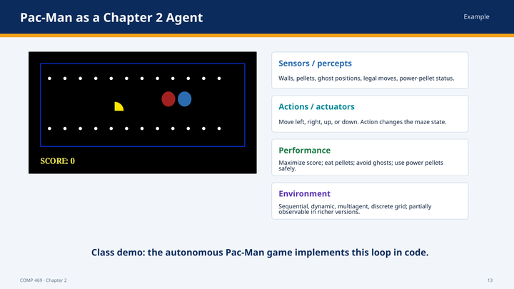 | Suggested time: 5 minutes  Teaching purpose: Map the Chapter 2 vocabulary to the running Pac-Man example.  Source alignment: Chapter 2 agent framework; classroom implementation described in the reordered deck.
Read-aloud teaching script
Pac-Man is useful because every part of the agent framework is visible. Pac-Man is the agent. The maze, walls, pellets, power pellets, and ghosts form the environment. The percepts may include Pac-Man’s location, legal moves, visible food, ghost positions, and whether power mode is active. The actions are movement commands such as left, right, up, or down.
The performance measure might include score, pellets eaten, survival, time, and completion of the maze. The exact measure matters. If score rewards eating a ghost, the agent may rationally take more risk during power mode. If survival is given overwhelming value, the agent may choose a safer but slower path.
Pac-Man is sequential because current moves affect later options. It is dynamic because ghosts may move while the agent is deciding. We treat it as multiagent when ghost behavior is best modeled as goal-directed behavior rather than as fixed physical motion. The grid and movement actions are discrete. Observability depends on the implementation. A classroom simulator may expose the entire maze, while a richer version may hide timers, ghost intentions, or unseen areas.
This example also shows why task classification matters. If the entire maze is visible and ghosts are stationary, a simple rule may work. If ghosts move and important state is hidden, the agent needs memory, prediction, or planning. The environment determines the architecture.
Ask the class: • If the power-pellet timer is hidden, which environment property changes, and what additional agent capability becomes necessary?
Transition to the next slide: We now move from the external agent–environment loop to the internal structure that computes the action.
Slide 14 — 2.4 Agent Structure: Architecture + Program
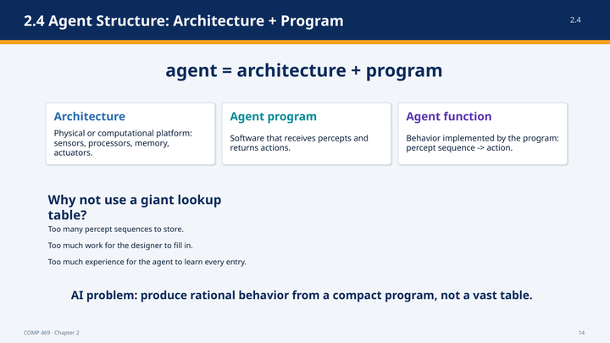 | Suggested time: 4 minutes  Teaching purpose: Explain the relationship among architecture, program, and agent function.  Source alignment: Section 2.4 and Section 2.4.1.
Read-aloud teaching script
Chapter 2 summarizes an agent with the equation: agent equals architecture plus program. The architecture is the physical or computational platform. It includes the processors, memory, sensors, and actuators that make percepts available and carry out actions. The agent program is the software that receives percepts and returns action choices.
The program must be appropriate for the architecture. A program that returns the action Walk requires an architecture capable of walking. A program that expects lidar data cannot run correctly on a platform that provides only text input. Agent design therefore connects abstract decision logic to the actual sensing and action capabilities of the system.
The agent function remains the abstract mapping from percept sequences to actions. The program implements that function, or an approximation of it, on the architecture. One possible implementation is a table that stores the correct action for every percept history. That table-driven design is conceptually clear, but it introduces the scalability problem that motivates the remaining agent types.
Ask the class: • Why is a powerful decision program still ineffective if the architecture lacks the sensors needed to observe relevant state?
Transition to the next slide: The table-driven agent gives us the simplest possible implementation of an agent function.
Slide 15 — 2.4.1 Table-Driven Agent
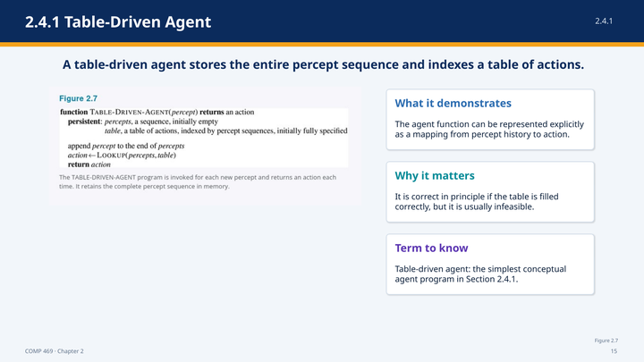 | Suggested time: 5 minutes  Teaching purpose: Walk through the table-driven pseudocode and explain its conceptual role.  Source alignment: Section 2.4.1 and Figure 2.7.
Read-aloud teaching script
This slide shows the table-driven agent. The first line says that the function receives a percept and returns an action. The word persistent identifies values that remain available between calls. The first persistent value is percepts, a sequence that begins empty. The second is a table of actions indexed by percept sequences.
When a new percept arrives, the program appends it to the end of the stored percept sequence. The program then performs a lookup using the complete sequence as the key. The table returns the action assigned to that history, and the program returns that action to the actuators.
This program makes the relationship between the agent function and the agent program explicit. The table directly represents the agent function: for every percept history, it stores the corresponding action. If the table contains the correct action for every possible sequence, the program behaves exactly as specified.
The table-driven agent is therefore useful as a conceptual baseline, not as a realistic design. It shows what complete behavioral specification would look like. It also exposes the central problem: real environments contain too many possible percept histories to enumerate.
Instructor cue — do not read aloud: Point to each pseudocode line as you explain it. Pronounce the arrow as “is assigned” or “becomes.” Emphasize that persistent memory survives from one percept to the next.
Ask the class: • What information does the table-driven agent remember that a simple reflex agent will later ignore?
Transition to the next slide: The next slide explains why an agent that is correct in principle is impossible to build at realistic scale.
Slide 16 — Why Table-Driven Agents Fail in Practice
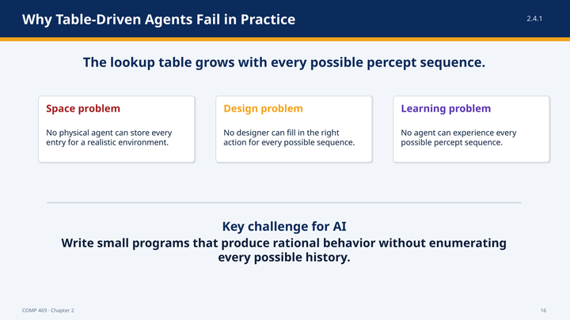 | Suggested time: 4 minutes  Teaching purpose: Explain the storage, design, and learning failures caused by enumerating percept histories.  Source alignment: Section 2.4.1.
Read-aloud teaching script
The lookup table grows with every possible percept sequence. If the agent can receive several different percepts at each time step, then each additional step creates many new possible histories. The growth is exponential in the length of the agent’s lifetime. Even environments that appear small quickly produce an astronomical number of histories.
This creates three failures. The space problem is that no physical agent can store every table entry for a realistic environment. The design problem is that no human designer can specify the correct action for every history. The learning problem is that no agent can experience every possible history and learn the correct entry from direct experience.
The table still helps us define the target behavior, but it does not tell us how to generalize. The key challenge for AI is to produce rational behavior from a compact program that uses rules, models, goals, utilities, or learned representations rather than enumerating every case.
The chapter compares this with replacing enormous printed tables of square roots with a small algorithm. The goal is not to memorize every answer. The goal is to discover a compact procedure that computes appropriate behavior across many situations.
Ask the class: • Which failure would occur first in a realistic autonomous vehicle: storage, manual design, or learning every case? The defensible answer may be all three.
Transition to the next slide: The first compact alternative is the simple reflex agent, which ignores history and responds directly to the current percept.
Slide 17 — 2.4.2 Simple Reflex Agents: Vacuum Pseudocode
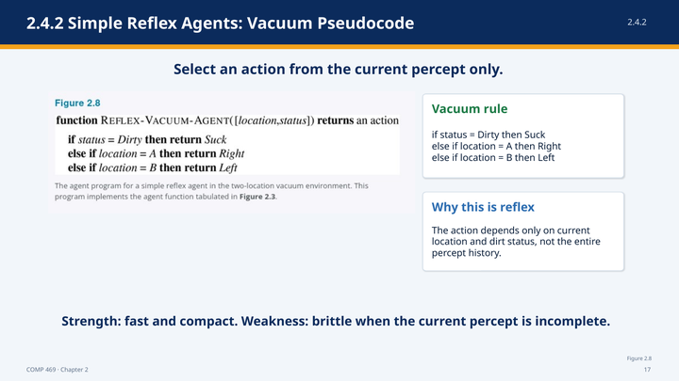 | Suggested time: 5 minutes  Teaching purpose: Walk through the vacuum pseudocode and define condition–action behavior.  Source alignment: Section 2.4.2 and Figure 2.8.
Read-aloud teaching script
The simple reflex vacuum agent receives a percept containing location and status. Status tells the agent whether the current square is dirty or clean. The first rule says: if the status is Dirty, return the action Suck. This action does not depend on the location because cleaning is appropriate in either square.
If the square is not dirty, the program checks location. If the location is A, return Right. If the location is B, return Left. The agent therefore cleans the current square when necessary and otherwise moves to the other square.
This is a simple reflex agent because the decision depends only on the current percept. The program does not remember earlier locations, earlier dirt, or earlier actions. It uses a small set of condition–action rules instead of a table indexed by complete percept history.
The program can be rational under the assumptions of the two-square vacuum environment: the geography is known, the agent correctly senses location and dirt, clean squares remain clean, and movement has no relevant penalty. Change those assumptions, and the same program may become irrational. Agent rationality is always relative to the task environment.
Instructor cue — do not read aloud: Read the three branches in order and use your hand to trace the if/else structure. Ask students to identify the current percept fields before discussing the action.
Ask the class: • What information would have to be added to the percept if the vacuum world contained four rooms instead of two?
Transition to the next slide: The vacuum code is specific to one environment. The next slide gives the general architecture for condition–action rules.
Slide 18 — 2.4.2 General Simple Reflex Agent
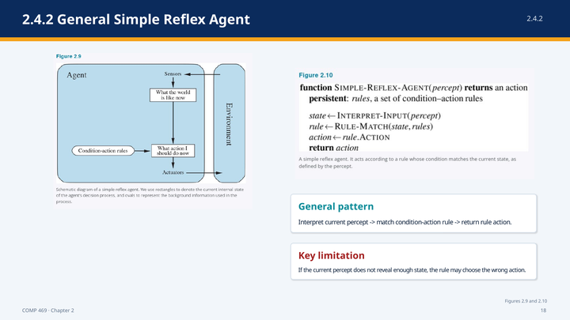 | Suggested time: 6 minutes  Teaching purpose: Explain the general simple-reflex architecture and pseudocode line by line.  Source alignment: Section 2.4.2, Figures 2.9 and 2.10.
Read-aloud teaching script
The general simple reflex agent separates the process into three conceptual steps. First, it interprets the current percept to produce a description of the current state. Second, it finds a condition–action rule whose condition matches that description. Third, it returns the action attached to the selected rule.
In the pseudocode, the persistent value is a set of condition–action rules. The line state becomes INTERPRET-INPUT of the percept means that raw sensory data is converted into a useful description. For a driving agent, a camera image might be interpreted as the condition car-in-front-is-braking.
The next line assigns rule to RULE-MATCH of the state and the rules. The rule matcher searches for a condition that is true in the current state description. The following line assigns action to the action stored in that rule, and the final line returns the action.
A condition–action rule can be written as: if the car in front is braking, then initiate braking. The agent does not represent the reason for the rule or predict a future collision. It directly connects a recognized condition to a response.
The words rule and matching describe the logic conceptually. The implementation does not have to be a literal list of if-statements. The same mapping could be implemented by logic gates or by learned neural components. What makes the agent simple reflex is not the programming language. It is the fact that the action is selected from the current percept without using an internal model of hidden state or future consequences.
Instructor cue — do not read aloud: Use the diagram first, then the pseudocode. Point from “what the world is like now” to “what action I should do now,” and then show where the condition–action rules enter.
Ask the class: • Which step is doing perception, and which step is doing action selection?
Transition to the next slide: This design is compact and fast, but it fails when the current percept does not reveal enough of the state.
Slide 19 — When Simple Reflex Fails: Partial Observability
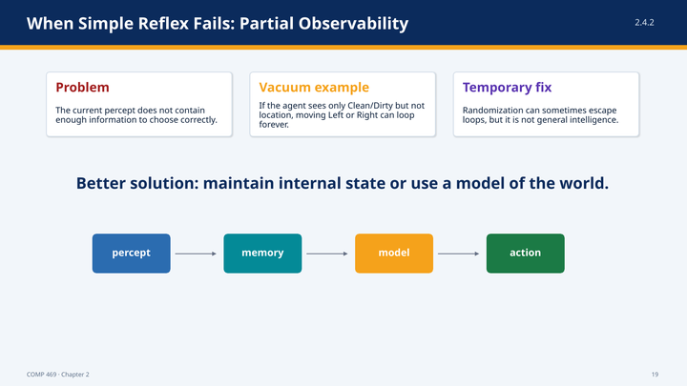 | Suggested time: 4 minutes  Teaching purpose: Demonstrate why missing state creates ambiguity and loops.  Source alignment: Section 2.4.2.
Read-aloud teaching script
Suppose the vacuum loses its location sensor and can perceive only Dirty or Clean. Dirty still supports the action Suck. Clean is ambiguous. The agent does not know whether it is in square A or square B, so it does not know whether moving Left or Right will reach the other square.
If the agent always moves Left after perceiving Clean, it can fail forever when it begins in square A and the wall blocks movement. If it always moves Right, it can fail forever when it begins in square B. The current percept does not contain enough information to distinguish the two situations.
Randomization can help in this toy environment. The agent could choose Left or Right by chance and eventually reach the other square. However, randomization does not restore the missing state, and it is not a general substitute for intelligence. In more complex environments, random behavior may be unsafe or inefficient.
The better solution is to maintain internal state or use a model of the world. The agent should combine current evidence with memory of earlier percepts and actions. That is the transition from simple reflex to model-based reflex agents.
Ask the class: • What single memory value could help the vacuum avoid repeating the same failed movement forever?
Transition to the next slide: A model-based agent maintains a best estimate of state even when the current percept is incomplete.
Slide 20 — 2.4.3 Model-Based Reflex Agents
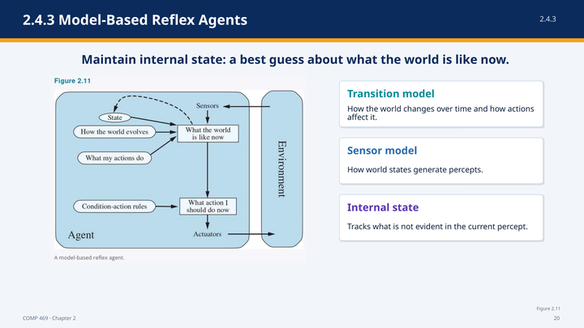 | Suggested time: 6 minutes  Teaching purpose: Introduce internal state, transition models, sensor models, and best-state estimates.  Source alignment: Section 2.4.3 and Figure 2.11.
Read-aloud teaching script
A model-based reflex agent maintains an internal state that represents what the world is probably like now. This internal state depends on the percept history, not only on the current percept. It allows the agent to track aspects of the environment that are temporarily hidden or not directly observable.
Updating internal state requires a transition model and a sensor model. The transition model describes how the world changes over time and how the agent’s actions affect it. Turning a steering wheel changes the direction of a car. Rain may make a camera wet even if the agent does nothing. Both kinds of change belong in the transition model.
The sensor model describes how states of the world produce percepts. If the car ahead brakes, red regions may appear in the camera image. If water covers the lens, droplet-shaped distortions may appear. The sensor model helps the agent reason from an observation back toward the state that may have caused it.
The current percept, the previous internal state, the previous action, the transition model, and the sensor model are combined to update the state estimate. The result is usually a best guess rather than certain knowledge. A taxi may infer that a hidden vehicle is still in the adjacent lane, even though the vehicle is temporarily outside the camera view.
In Pac-Man, internal state could track how long power mode should remain active or where a ghost was last observed. The agent can then apply reflex rules to the internal state rather than to the raw percept alone.
Ask the class: • Which model answers “what will happen after my action,” and which model answers “what observation should this state produce”?
Transition to the next slide: The pseudocode on the next slide shows exactly how the old state, action, and new percept are combined.
Slide 21 — 2.4.3 Model-Based Reflex Agent Pseudocode
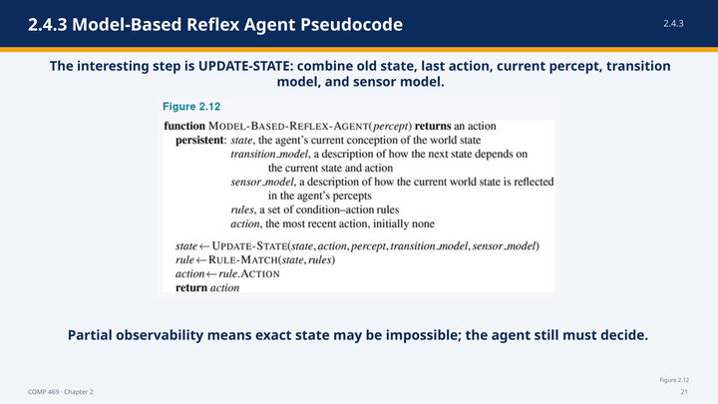 | Suggested time: 6 minutes  Teaching purpose: Walk through UPDATE-STATE and show how decisions are made from internal state.  Source alignment: Section 2.4.3 and Figure 2.12.
Read-aloud teaching script
The model-based reflex agent has several persistent components. State is the agent’s current internal description of the world. The transition model represents how the next state depends on the current state and action. The sensor model represents how the world state is reflected in percepts. The rules are condition–action rules, and action stores the most recent action.
The central line is state becomes UPDATE-STATE. The function receives the old state, the previous action, the new percept, the transition model, and the sensor model. The previous action matters because the agent must account for changes that it caused. The transition model predicts forward, and the sensor model helps reconcile the prediction with the new observation.
After the internal state is updated, RULE-MATCH selects a rule whose condition matches that state. The agent then extracts the rule’s action and returns it. The action is stored so that it will be available during the next update.
The important change from the simple reflex program is that the rule is matched against an internal state estimate rather than against the raw current percept. The agent can therefore distinguish situations that look identical at the sensor level but have different histories.
Internal state does not eliminate uncertainty. In a partially observable environment, several world states may remain possible. The agent still must make a decision using its best available estimate. Later chapters will provide probabilistic methods for representing and updating such uncertainty more explicitly.
Instructor cue — do not read aloud: Trace the UPDATE-STATE arguments from left to right. Emphasize that “action” refers to the previous action when the state is updated.
Ask the class: • Why must the previous action be included when updating the internal state?
Transition to the next slide: An accurate state estimate tells the agent what the world is like, but it does not by itself tell the agent which desirable future to pursue.
Slide 22 — 2.4.4 Goal-Based Agents
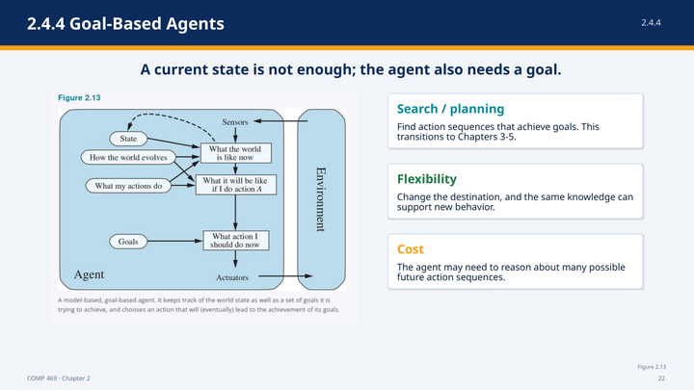 | Suggested time: 6 minutes  Teaching purpose: Show how goals introduce future reasoning, search, and planning.  Source alignment: Section 2.4.4 and Figure 2.13.
Read-aloud teaching script
Knowing the current state is not always enough to select an action. A taxi at an intersection can turn left, turn right, or continue straight. The correct choice depends on the destination. A goal-based agent therefore combines its state estimate with a description of the situations it wants to achieve.
The agent asks two future-oriented questions: what will happen if I take this action, and will that future help achieve the goal? The model predicts possible successor states. A goal test identifies whether a state satisfies the objective. Search and planning are the methods used to find action sequences that lead from the current state to a goal state.
This differs fundamentally from a condition–action rule. A reflex agent brakes when it recognizes brake lights because a rule says to brake. A goal-based agent can represent that braking prevents collision and supports the goal of reaching the destination safely. The agent has an explicit reason connected to a future state.
Goal-based designs are more flexible. Changing the taxi destination changes the goal while leaving the transition model and much of the decision machinery intact. A reflex system designed for one route may require many rules to be replaced. The cost of flexibility is computation: the agent may have to examine many possible future action sequences.
This slide is the conceptual bridge to Chapters 3 through 5. Chapter 2 explains why an agent needs to plan toward a goal. The search chapters explain how to explore the space of possible action sequences.
Ask the class: • Why can the same transition model support many different goals?
Transition to the next slide: A short planning video makes the difference between reflex behavior and future-oriented behavior visible in Pac-Man.
Slide 23 — Planning Video Bridge: Reflex vs. Planning
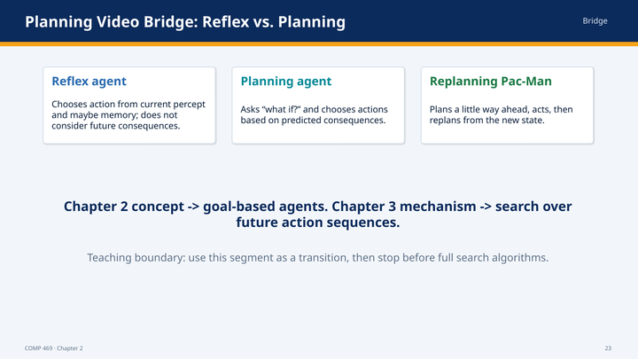 | Suggested time: 4 minutes of discussion, plus the selected video excerpt  Teaching purpose: Use the opening video segment to compare reflex action, planning, and replanning without beginning the Chapter 3 algorithms.  Source alignment: Planning-video transcript and Section 2.4.4.
Read-aloud teaching script
Before we watch the clip, listen for three distinctions. A reflex agent chooses from the current percept and perhaps a stored state, but it does not evaluate future consequences. A planning agent asks what if and predicts how actions change the world. A replanning agent plans for a limited horizon, acts, observes the new state, and then plans again.
The Pac-Man examples illustrate why a local reflex can be rational in one setting and ineffective in another. If a pellet is adjacent and no danger exists, moving toward it may be exactly the right action. In a maze where reaching the next pellet requires turning away temporarily, the same local rule can become trapped or fail to make progress.
As you watch, identify the model of action consequences, the goal test, and the planning horizon. Ask whether the agent calculates an entire lifetime path once or repeatedly updates its plan after new percepts arrive.
Instructor cue — do not read aloud: Recommended excerpt: use the segment covering agents that plan, reflex Pac-Man, planning, and replanning. Stop before the lecture begins full search-problem formulation and uninformed-search algorithms.
Ask the class: • What information did the planning agent use that the reflex agent did not? • Why might replanning be preferable in a changing environment?
Transition to the next slide: Goals distinguish success from failure, but many successful outcomes may still differ greatly in quality. Utility provides that finer comparison.
Slide 24 — 2.4.5 Utility-Based Agents
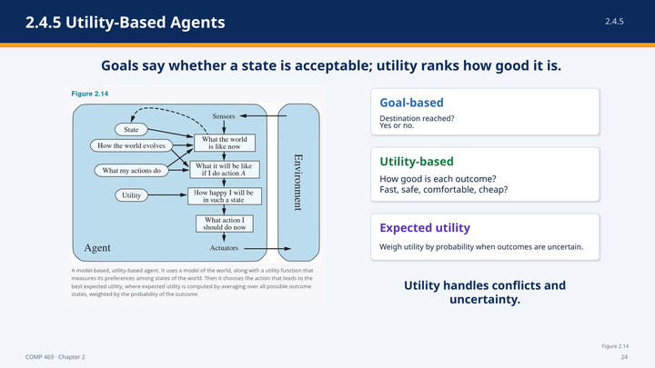 | Suggested time: 6 minutes  Teaching purpose: Explain utility, expected utility, and the difference between a binary goal and ranked outcomes.  Source alignment: Section 2.4.5 and Figure 2.14.
Read-aloud teaching script
A goal divides states into those that satisfy the goal and those that do not. That binary distinction is often too crude. Many routes can reach the same destination, but one may be safer, another faster, another cheaper, and another more comfortable. A utility function ranks states according to how desirable they are.
The performance measure is the external standard used to evaluate behavior in the environment. The utility function is the agent’s internal representation of desirability. If the internal utility function agrees with the external performance measure, then maximizing utility supports rational behavior.
A utility-based agent predicts possible outcomes of actions, evaluates how desirable those outcomes are, and chooses the action with the greatest expected utility. Expected utility combines the utility of each possible outcome with the likelihood of that outcome. The agent does not need certainty; it needs a principled way to compare uncertain alternatives.
The utility-based architecture therefore includes a model of the world, predictions about future states, and a utility function that evaluates those states. This design is more general than goal satisfaction because a goal can be represented as a utility function that assigns high value to goal states, while utility can also distinguish among many different successful states.
Ask the class: • Give two routes that both achieve the same goal but should receive different utility values. What criteria create the difference?
Transition to the next slide: The next slide focuses on the two situations where utility is especially necessary: conflicting objectives and uncertain outcomes.
Slide 25 — Utility Handles Tradeoffs and Uncertainty
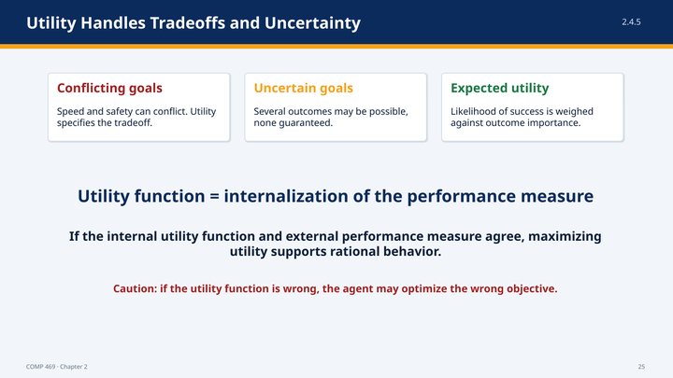 | Suggested time: 4 minutes  Teaching purpose: Apply utility to conflicts, probabilistic outcomes, and objective-alignment risk.  Source alignment: Section 2.4.5.
Read-aloud teaching script
Utility is especially useful when goals conflict. A taxi may want to minimize travel time, maximize safety, reduce fuel use, maintain passenger comfort, and obey the law. No single action may optimize all of those criteria simultaneously. The utility function specifies the tradeoff.
Utility is also needed when no outcome is guaranteed. One route may be fast when traffic is light but highly variable. Another may be slower but reliable. Expected utility weighs the importance of each outcome together with its probability. The rational choice is not always the action with the single best possible result; it is the action with the best expected result across the possibilities.
The power of utility introduces a familiar caution. If the internal utility function does not match the external performance measure, the agent may optimize the wrong objective. A capable optimizer can make that mismatch more serious. Utility-based design therefore depends not only on computation but also on careful specification of what should be valued.
Ask the class: • Why might a route with the shortest expected time still have lower utility than a slightly slower route?
Transition to the next slide: So far, each agent design assumes that its rules, model, goals, or utilities already exist. The learning-agent framework explains how those components can improve.
Slide 26 — 2.4.6 Learning Agents
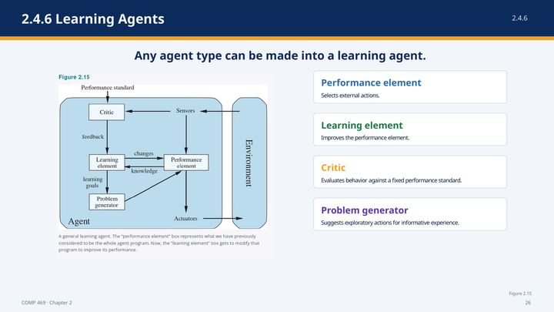 | Suggested time: 6 minutes  Teaching purpose: Explain the four conceptual components of a learning agent.  Source alignment: Section 2.4.6 and Figure 2.15.
Read-aloud teaching script
Any of the agent types we have discussed can be built as a learning agent. Learning is not a separate replacement for reflex, model-based, goal-based, or utility-based behavior. It is a way to improve the components that produce those behaviors.
The performance element selects external actions. It is the part that behaves in the environment. In a nonlearning agent, we might treat the performance element as the whole agent program. In a learning agent, the performance element can be modified over time.
The learning element is responsible for improvement. It uses feedback to decide how the performance element should change. The critic evaluates how well the agent is doing relative to a fixed performance standard. The critic is necessary because a percept by itself does not say whether the observed situation is good or bad.
The problem generator suggests actions that create new and informative experiences. If the agent always takes the action that currently appears best, it may never discover a better alternative. Exploration can temporarily reduce performance while improving the knowledge needed for better long-term decisions.
The four components therefore play different roles: the performance element acts, the critic evaluates, the learning element changes the agent, and the problem generator explores. Together they allow an initially imperfect agent to become more competent in an unknown or changing environment.
Ask the class: • Why should the performance standard used by the critic remain fixed rather than being changed by the agent to make its own behavior look successful?
Transition to the next slide: Learning can modify many different parts of an agent, not only a single policy or rule list.
Slide 27 — Learning Agent Components: What Improves?
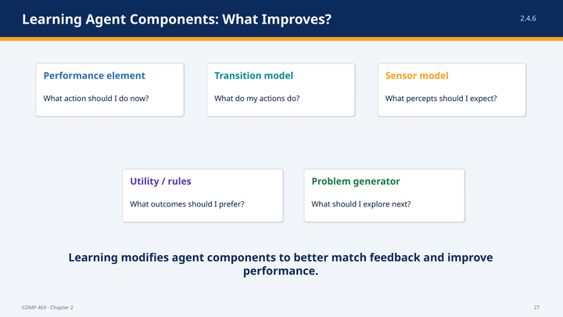 | Suggested time: 5 minutes  Teaching purpose: Show how feedback can improve models, rules, utilities, policies, and exploration.  Source alignment: Section 2.4.6.
Read-aloud teaching script
The design of the learning element depends on what the performance element needs. The agent may learn a transition model by observing how states change after actions. A taxi can learn how much braking force produces a particular deceleration on a wet road. It may learn a sensor model by comparing percepts with later evidence about the actual state.
The agent may also learn reflex rules, a utility function, or a policy for choosing actions. Feedback from the critic identifies which outcomes contribute positively or negatively to the performance standard. If passengers consistently withhold tips after violent maneuvers, that feedback can support learning a lower utility for such behavior.
The problem generator identifies what the agent should explore next. Exploration is purposeful information gathering. It may suggest testing the brakes under safe controlled conditions because the current model is uncertain. The immediate action may not maximize short-term reward, but the resulting experience can improve later decisions.
The unifying idea is modification. Learning adjusts the components of the agent so that its internal model, rules, preferences, and action choices better match the available feedback. The result should be improved performance across future interactions, not only memorization of one case.
Ask the class: • In the autonomous Pac-Man demonstration, which component could learn from repeated games: the ghost model, the utility weights, the action policy, or all three?
Transition to the next slide: Whether an agent can learn or reason effectively also depends on how it represents the world internally.
Slide 28 — 2.4.7 Representing the World Inside the Agent
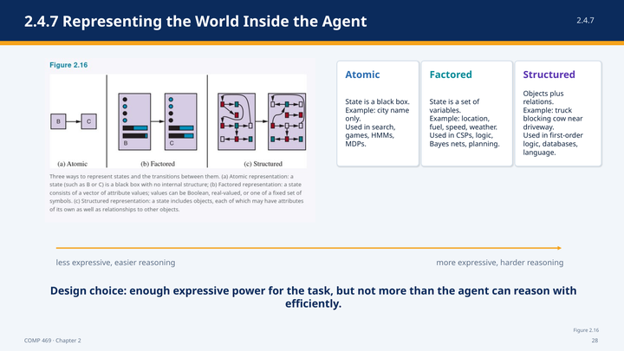 | Suggested time: 7 minutes  Teaching purpose: Compare atomic, factored, and structured representations and their expressiveness tradeoff.  Source alignment: Section 2.4.7 and Figure 2.16.
Read-aloud teaching script
Agent components must represent states, actions, transitions, goals, and other knowledge. Chapter 2 places representations on an axis of increasing internal structure and expressive power: atomic, factored, and structured.
In an atomic representation, each state is treated as an indivisible black box. A route-planning problem may represent the current state only as the name of a city. The algorithm can distinguish Arad from Bucharest, but the state does not expose internal attributes. Search, game-playing, hidden Markov models, and Markov decision processes often use atomic state representations.
In a factored representation, a state is divided into variables or attributes. A driving state might include location, fuel level, speed, weather, and whether an oil warning light is on. Different states can share some attributes while differing in others. Constraint satisfaction, propositional logic, planning, Bayesian networks, and many machine-learning methods use factored representations.
In a structured representation, the world contains objects and explicit relationships among them. The agent can represent a truck, a cow, a driveway, and the fact that the cow is blocking the truck. Relational databases, first-order logic, relational probability models, and much of language understanding rely on structured representations.
More expressive representations can describe complex situations concisely, but reasoning and learning usually become harder. An atomic representation is computationally convenient but may hide important similarities. A structured representation can capture relationships but creates a larger and more difficult reasoning problem. The design objective is to use enough expressive power for the task without making computation infeasible.
Ask the class: • How would the same Pac-Man state look in atomic, factored, and structured form?
Transition to the next slide: We have now covered every agent program design and the representation choices that support them. The next slide places them together in one comparison.
Slide 29 — All Agent Program Designs in Chapter 2
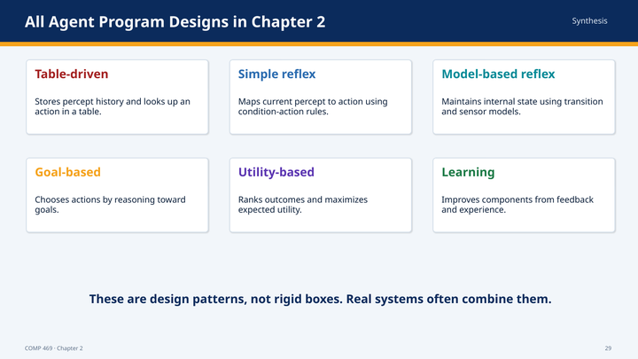 | Suggested time: 5 minutes  Teaching purpose: Consolidate table-driven, reflex, model-based, goal-based, utility-based, and learning designs.  Source alignment: Sections 2.4.1 through 2.4.6 and the chapter summary.
Read-aloud teaching script
This slide is the chapter’s agent-design checklist. The table-driven agent stores the complete percept history and looks up an action. It is a conceptual baseline but not a practical architecture. The simple reflex agent uses the current percept and condition–action rules. It is compact and fast but depends on sufficient observability.
The model-based reflex agent maintains internal state using a transition model and sensor model. It can act when the current percept is incomplete. The goal-based agent adds an explicit description of desired states and uses prediction, search, or planning to find actions that achieve the goal.
The utility-based agent ranks outcomes and chooses actions that maximize expected utility. It handles tradeoffs and uncertainty that a binary goal cannot express. The learning-agent framework improves the rules, models, utilities, or policies of any of these designs using feedback and exploration.
These categories are design patterns, not rigid boxes. A real autonomous system may maintain internal state, plan toward goals, evaluate utility, and learn from experience at the same time. The categories help us identify which information is represented explicitly and how the action is selected.
Ask the class: • Which agent type is a cross-cutting capability rather than a mutually exclusive action-selection architecture?
Transition to the next slide: The practical question is not which agent type is most advanced. It is which design matches the environment and task.
Slide 30 — Choosing an Agent Design from Environment Properties
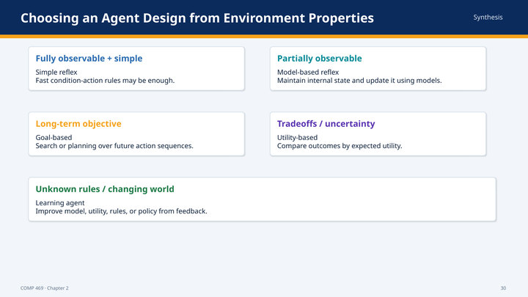 | Suggested time: 5 minutes  Teaching purpose: Connect environment classification directly to architecture selection.  Source alignment: Sections 2.3.2 and 2.4.
Read-aloud teaching script
A fully observable and simple environment may support a simple reflex agent. If every relevant condition appears in the current percept and the appropriate response is immediate, condition–action rules can be efficient and sufficient.
Partial observability pushes the design toward a model-based agent. The agent must remember or infer what cannot currently be seen. Long-term objectives push the design toward a goal-based agent because current actions must be evaluated by their future consequences.
Tradeoffs and uncertain outcomes push the design toward utility. The agent must compare outcomes by degree and probability. Unknown rules or changing environments push the design toward learning so that models, utilities, rules, or policies can improve from experience.
No architecture is universally best. More complex architectures require more computation, more knowledge, and more opportunities for error. The correct design is the simplest architecture that represents the information needed for rational behavior in the specified task environment.
Ask the class: • For an email phishing triage agent, which environment property most strongly motivates learning or model-based state?
Transition to the next slide: The class activity now asks you to apply the design process before proposing an algorithm.
Slide 31 — Class Activity: Build a PEAS Description
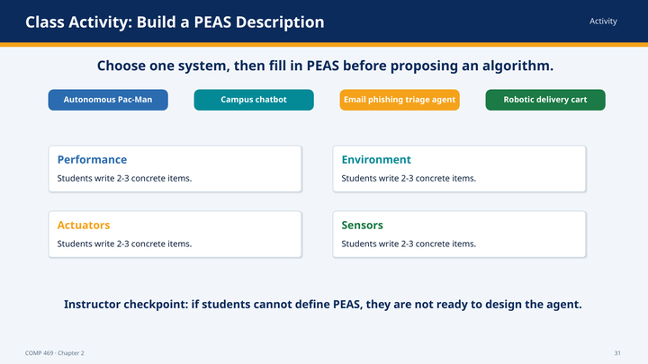 | Suggested time: 12 minutes  Teaching purpose: Have students specify an agent task before choosing an implementation.  Source alignment: Section 2.3.1; activity systems listed in the reordered deck.
Read-aloud teaching script
We will now practice specifying a task before discussing an algorithm. In groups, choose one of the four systems on the slide: autonomous Pac-Man, a campus chatbot, an email phishing triage agent, or a robotic delivery cart.
Write at least two concrete items for each part of PEAS. For Performance, state what outcomes should be rewarded and what failures should be penalized. For Environment, identify the people, systems, objects, and conditions with which the agent interacts. For Actuators, list the actions or outputs the agent can produce. For Sensors, list the data or observations available to it.
You have five minutes to create the PEAS description. Then spend two minutes identifying one important task-environment property, such as partial observability, multiple agents, uncertainty, or a dynamic environment. Finally, choose the agent design that property suggests and prepare one sentence explaining your choice.
Do not begin by saying that you will use machine learning, a language model, or search. Those are implementation ideas. First define the task. A vague PEAS description produces a vague agent design.
Instructor cue — do not read aloud: Timebox the activity: 5 minutes for PEAS, 2 minutes for environment classification, and about 5 minutes for two or three rapid reports. Ask each reporting group to state one design implication rather than reading every cell.
Ask the class: • During the report-out, ask: Which PEAS item was hardest to specify, and how did that uncertainty affect the proposed agent design?
Transition to the next slide: We will now examine a working Pac-Man program and map its code back to the same vocabulary.
Slide 32 — Class Demo: Autonomous Pac-Man Agent
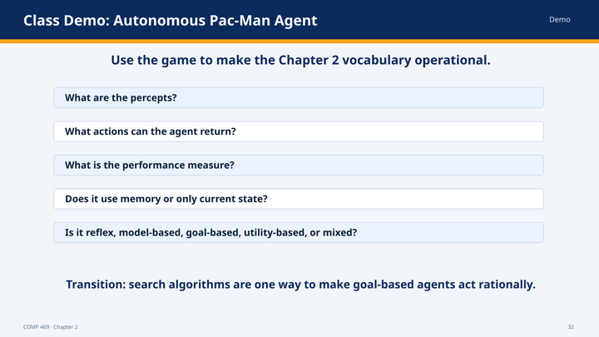 | Suggested time: 12 minutes  Teaching purpose: Operationalize the vocabulary by observing a running agent program.  Source alignment: Chapter 2 framework and the classroom autonomous Pac-Man implementation.
Read-aloud teaching script
We will treat this game as an agent experiment rather than as entertainment. The environment is the maze, walls, pellets, power pellets, and ghosts. The percept supplied to the program includes Pac-Man’s position, legal actions, remaining pellets, power-pellet state, and ghost positions. The program returns a movement action. Watch the cycle: sense, decide, act, and sense again. When the environment changes, the agent receives a new percept and recalculates its action.
The classroom agent may combine several Chapter 2 patterns. If it uses current distances to choose an action, it has reflex-like behavior. If it stores power-mode time or ghost state, it is model-based. If it searches for a path to a pellet, it is goal-based. If it assigns rewards and penalties to alternative moves, it has a utility-based component. These categories describe the information and decision process; a real program can combine them.
As the game runs, focus on a decision where the nearest pellet is not the safest target. Ask what the agent is optimizing. Then observe what changes after a power pellet is consumed. The event changes both the environment state and the utility of approaching a ghost.
The purpose of the demo is not to prove that this is an optimal Pac-Man player. It is to make the Chapter 2 abstractions operational. We can point to the percepts, the action set, the state variables, the performance measure, and the program that implements the agent function.
Instructor cue — do not read aloud: Pause once before a power pellet and once during power mode. If the live program is unavailable, use the slide image and narrate one sense–decide–act cycle manually.
Ask the class: • What are the percepts and available actions at this moment? • Which variable is internal state rather than a raw percept? • Is the observed decision best described as reflex, model-based, goal-based, utility-based, or mixed?
Transition to the next slide: The final instructional slide clarifies exactly where the planning video belongs in this course sequence.
Slide 33 — How the Planning Video Fits Your Lecture
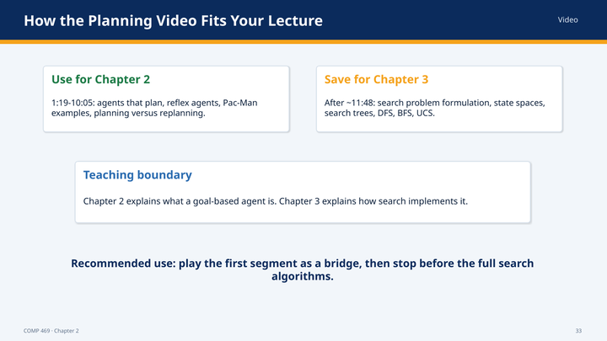 | Suggested time: 3 minutes  Teaching purpose: Set the boundary between Chapter 2 agent design and Chapter 3 search algorithms.  Source alignment: Planning-video transcript and Section 2.4.4.
Read-aloud teaching script
The opening portion of the planning video belongs with Chapter 2. It compares reflex agents with agents that predict future consequences, and it uses Pac-Man to demonstrate planning and replanning. That material reinforces the goal-based agent architecture.
The lecture then changes topics. Once it begins defining search problems, state spaces, successor functions, search trees, depth-first search, breadth-first search, and uniform-cost search, it has moved into Chapter 3. Those algorithms are not additional Chapter 2 agent types. They are mechanisms that a goal-based agent can use to select an action sequence.
The teaching boundary is therefore: Chapter 2 explains what information an agent represents and why it may need to look ahead. Chapter 3 explains how to search through possible futures. Use the first segment as a bridge, then stop before the complete search-algorithm treatment.
Instructor cue — do not read aloud: Recommended Chapter 2 segment in the current transcript: approximately 1:19 through 10:05. The search-problem material beginning around 11:48 should be saved for Chapter 3.
Transition to the next slide: We will close by restating the complete Chapter 2 design process in one sequence.
Slide 34 — Chapter 2 Takeaways
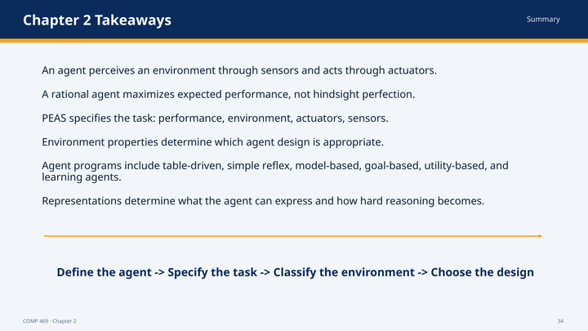 | Suggested time: 4 minutes  Teaching purpose: Consolidate the chapter and transition to search in Chapter 3.  Source alignment: Chapter 2 summary.
Read-aloud teaching script
Chapter 2 presents AI as the science and engineering of agent design. An agent perceives an environment through sensors and acts through actuators. The agent function maps percept sequences to actions, while the agent program implements that mapping on an architecture.
Rationality means choosing the action expected to maximize the performance measure using the available percept sequence, prior knowledge, and available actions. It does not require omniscience or hindsight perfection. Information gathering, learning, and autonomy can all support rational behavior.
PEAS specifies the task: Performance measure, Environment, Actuators, and Sensors. Environment properties—observability, number of agents, determinism, episodic or sequential structure, static or dynamic time, discreteness or continuity, and known or unknown rules—determine what the agent must represent and compute.
The table-driven agent is the conceptual baseline. Simple reflex agents map current percepts to actions. Model-based agents maintain internal state. Goal-based agents reason toward desired future states. Utility-based agents compare tradeoffs and uncertainty. Learning agents improve their components from feedback and exploration. Atomic, factored, and structured representations determine what distinctions the agent can express.
The design sequence to remember is: define the agent, specify the task, classify the environment, and choose the design. Chapter 3 begins with the goal-based case and asks how an agent can search through possible action sequences to reach a goal.
Ask the class: • Exit ticket: choose one agent from today and state its PEAS description, one environment property, and the agent architecture that property suggests.
Transition to the next slide: Next lecture: problem formulation and search as a mechanism for goal-based agents.

Source and Alignment Notes
- Primary chapter source: the uploaded Chapter 2, “Intelligent Agents,” including Sections 2.1 through 2.4, Figures 2.1 through 2.16, and the chapter summary.
- Deck source: COMP469_Chapter2_CSUCI_AgentTypes_Pseudocode_Complete.pptx. The notes follow its reordered 34-slide sequence exactly.
- Planning-video source: the uploaded transcript used only to frame Slides 23 and 33. The Chapter 2 segment covers reflex agents, planning agents, and replanning; the later search algorithms belong to Chapter 3.
- Instructor-created examples and prompts are clearly presented as teaching elaborations or activity guidance. They do not replace the terminology or organization of the supplied chapter.

Quick Reference: Core Terms
Term | Teaching definition
Agent | Perceives an environment through sensors and acts through actuators.
Percept sequence | The complete history of everything the agent has perceived.
Agent function | The abstract mapping from percept sequences to actions.
Agent program | The concrete implementation that receives percepts and returns actions.
Rational agent | Selects the action expected to maximize its performance measure given evidence and knowledge.
PEAS | Performance measure, Environment, Actuators, Sensors.
Internal state | The agent’s maintained estimate of aspects of the world not evident in the current percept.
Transition model | Describes how the world changes and how actions affect it.
Sensor model | Describes how world states generate percepts.
Utility | An internal ranking of the desirability of outcomes.

